**《软件项目组织与管理》课程作业**

**班级：14011907**

**学号：2019302789**

**姓名：梁芮槐**

# Chapter 11

## 11.1 Practice 4

**【Answer】**

Project1: 120000×0.5+(-50000)×0.5=35000

Project2: 100000×0.3+50000×0.4+(-60000)×0.3=32000

Project3: 20000×0.7+(-5000)×0.3=12500

Project4: 40000×0.3+30000×0.3+20000×0.2-50000×0.2=15000

Through EMV analysis, the expectations of projects one and two are relatively large, and the expectations of projects three and four are significantly lower than those of one and two. Although the expected value of project one is great, project one has a probability of loss of 50% and project two has a probability of loss of only 30%. Judging from my personal risk tolerance, I chose project two in the end.

## 11.2 Practice 5

**【Answer】**

Break-even analysis is a method of analyzing the balance between project costs and benefits through the break-even point (BEP). Changes in various uncertain factors (such as investment, cost, sales volume, product prices, project life, etc.) will affect the economic effects of the investment plan. When the changes in these factors reach a certain critical value, it will affect the choice of the plan. The purpose of break-even analysis is to find this critical value, the break-even point (BEP), to determine the ability of the investment plan to withstand changes in uncertain factors, and to provide a basis for decision-making.

Break-even analysis, also known as breakeven analysis or cost-profit analysis, is a mathematical analysis method based on the mutual restriction of product business volume (yield or sales volume), cost and profit. It is used to predict profit, control costs, and judge operating conditions. Generally speaking, enterprise income = cost + profit, if profit is zero, then all income = cost = fixed cost + variable cost, income = sales × price, variable cost = unit variable cost × sales volume, so Sales volume × price = fixed cost + unit variable cost × sales volume. From this, the formula for calculating the break-even point can be deduced as:

Break-even point (sales) = fixed cost ÷ unit measurement contribution difference

Corporate profit is the balance of sales revenue after deducting costs; sales revenue is the product of product sales and sales unit price; product costs include the total cost of factory costs and sales expenses, which are divided into fixed costs and variable costs.

The following are two examples of break-even analysis. You can change the sales price per unit and the number of manufacturing costs per unit by clicking the widget in the Excel document.

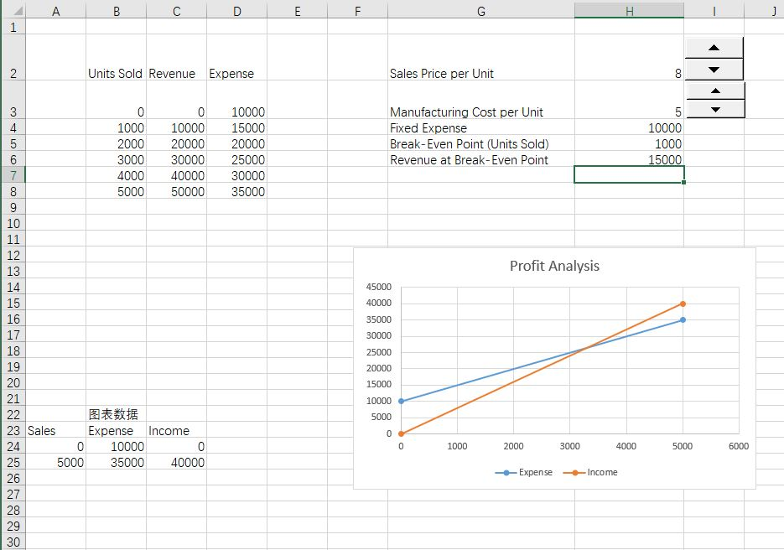

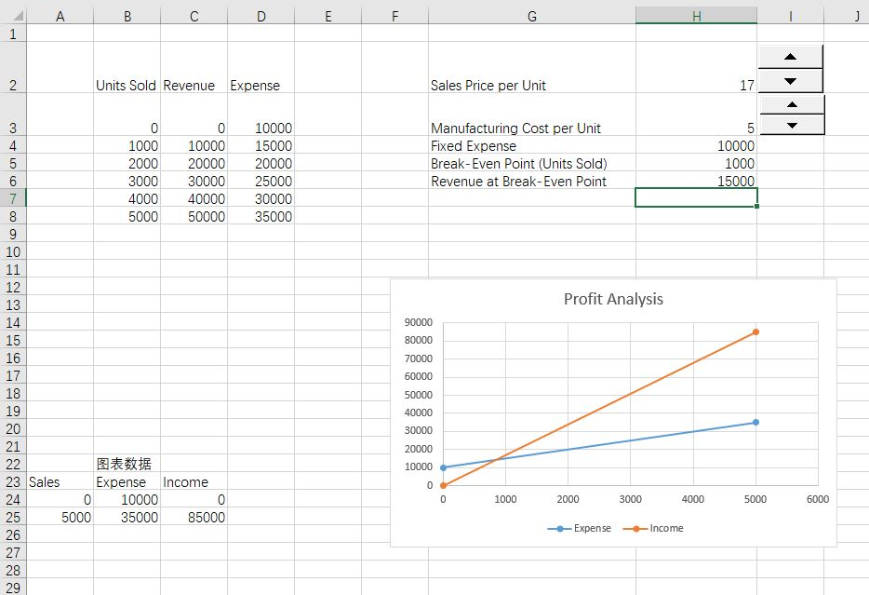

The break-even analysis can scientifically judge the project’s risk status and the project’s ability to withstand the uncertainties of various factors, and provide a basis for investment decisions. The traditional break-even analysis takes zero profit as the break-even point, and does not consider the time value of funds. It is a static analysis. The zero-profit break-even actually means that the project has lost the benchmark income level and the project has potential losses. By incorporating the time value of funds into the break-even analysis, the project’s break-even state is defined as a state where the net present value is zero. The time value of funds can be considered in the break-even analysis, which becomes the static break-even analysis of the dynamic break-even analysis. Since the economic essence of the net present value is that the project exceeds the benchmark income level during the entire economic calculation period, the excess net income expressed in present value, so the net present value of zero means that the project has just obtained the income benchmark income level and achieved the basic level of funds The preservation and the real "break-even". The dynamic break-even analysis not only considers the time value of funds, but also determines different break-even points according to the different benchmark rates of return required by the enterprise, so that the investment and operating decisions of the enterprise are more comprehensive and accurate, thereby improving the scientific and scientific nature of project investment decisions. reliability.

Sensitivity analysis is used to show the effect of changing one or more variables on the results. Separately increasing the unit sales price and reducing the unit manufacturing cost can advance the break-even point. When the two change at the same time, it depends on the relative size relationship between them.